**AZURE AD SSO Implementation**

Revision: 2.0

Date: 27/Feb/2024

For further information please contact:

[support@uppwise.com](mailto:support@uppwise.com)  
[www.uppwise.com](http://www.uppwise.com)

**AZURE AD SSO Implementation:**

For the implementation of SSO (Single Sign On) for the environment, using AZURE AD SAML we have described the steps below which need to be followed on the Azure portal.

1. **Microsoft Entra ID** -> Select Enterprise Application -> Create new Application

1. Go to the created application > Set up Single Sign On, using SAML

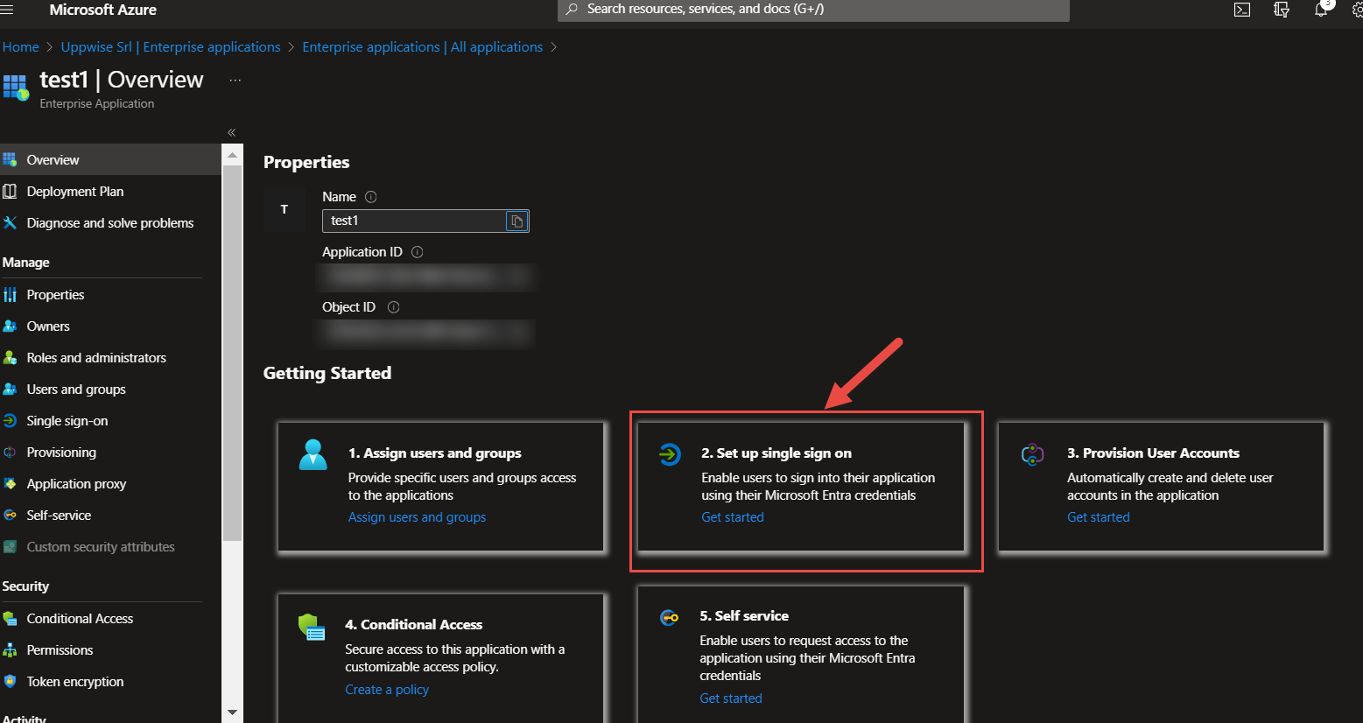

1. Set up Single Sign-On with SAML, please define the identifier and Reply URL

Identifier: <https://spm.uppwise.com/spm>

Reply URL: <https://spm.uppwise.com/spm/POAssertionService.aspx>

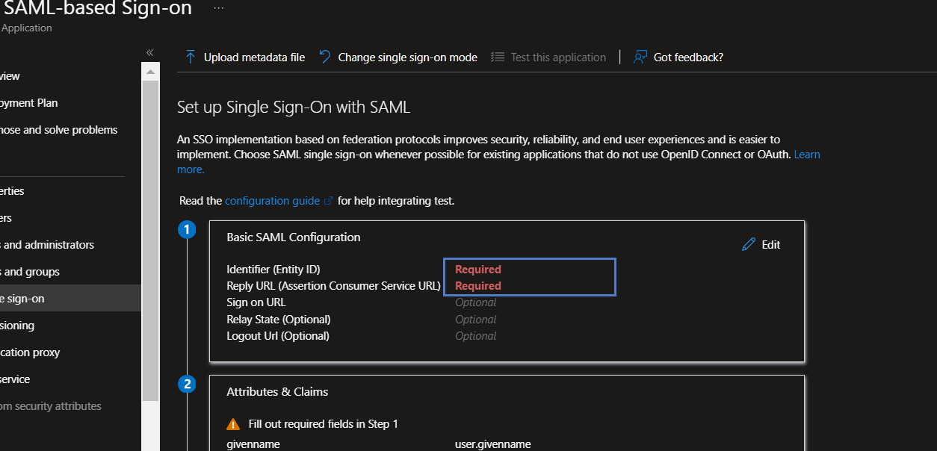

1. Define the User Attributes and Claims:

Please define **Email** as **NameID**, and **SamAccountName** as **user.mail**

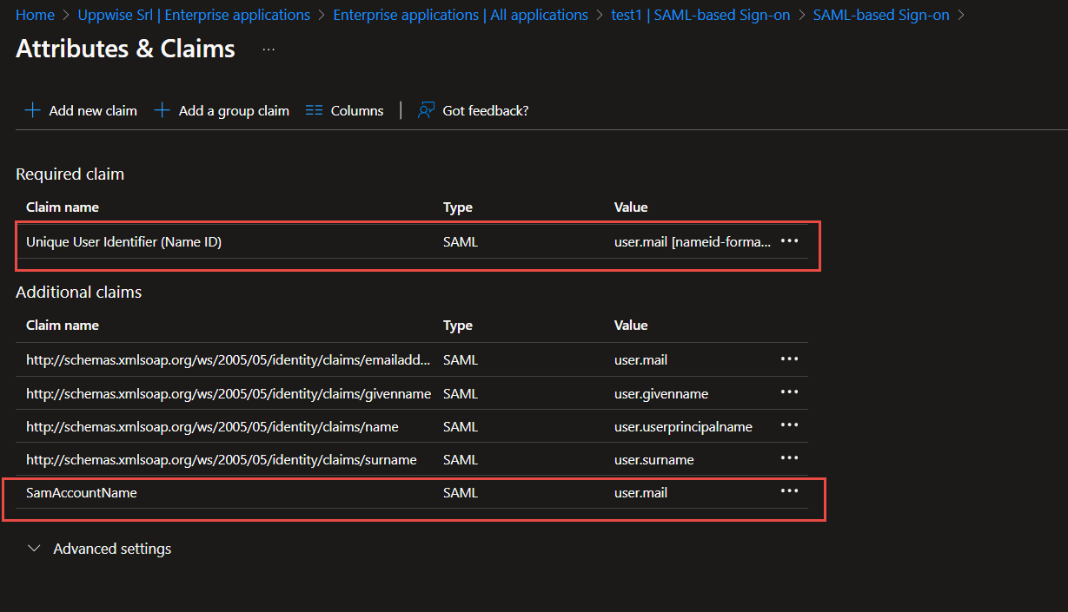

1. Under SAML Certificates define the **SHA-256** as Signing Algorithm

1. We will require the below **Login URL** and **Logout URL** for Accessing the SSO login.

